Site Goals

User Experience

Audience Definition

Scenarios

Scenario 1

Scenario 2

Scenario 3

Competitive Analysis Summary

Basically “competitive analysis” is a statement of the business strategy of the site, organisation, or company and how it relates to the competition. It determines the strengths and weaknesses of the current and potential competition.

In the case of “Tantra Australia,” it would appear that the competition is many but in fact it is limited. This is because “Tantra Australia” proclaims to teach a rare esoteric system. Also, Tantra Australia” is based on the clients’ published writings that state that there is a lost code that renders the religious scriptures of the world illegible without knowledge of this code. Therefore, “Tantra Australia” represents a major shift in messaging away from the competition. This is the sole purpose of the site to make this message available to spiritual seekers and this is the site’s primary competitive advantage. Unfortunately, this is not apparent to the customer as the clients are unknown. Also, “customer perception” can override the reality viewpoint. Past experience shows the clients that some customers find the revelation of the knowledge provided in these websites both threatening and disturbing. Therefore, the site has to slowly win over clients by appearing less intimidating. It does this for example in the Mela page where it invites practitioners of all denominations to practice Tantra. (The mela is well known as the kumbha mela in India held every twelve years.) So the main strength of “Tantra Australia” (its knowledge-base) is the weakness of its competitors. However, while the product is viable because it is unique, the marketing, promotion and advertising resources for the product are virtually non-existent. It is this that the site should endeavour to overcome along with conventional marketing strategies such as increased physical distribution of the clients writings to make the unique knowledge available. The “competitive analysis” with the other sites listed in this document indicates that with the exception of the monk at Buddhanet, the other sites were established businesses or institutions before launching their sites. Since the resources of mainstream publishing and distribution of books and magazines would not be available to the clients due to the controversial subject matter, the alternative is to, like the monk of Buddhanet, create a site of such proportions that it could gain at least equal competitive advantage with the other sites. This requires investment into the technologies mentioned in all the other sites that make them successful portals. Also the site should aim to better the competition in terms of the scope of its teachings, short learning timeframe, price and quality of venue where the retreats are held. This is because the site is directly competing with the leisuretime revenue of other retreat centres. The appearance of the site should also be unique; it should be spiritual, wholesome and integrated.

Site Content

Site Domain Name

Content Grouping and Labelling

Functional Requirements

Site Structure

Site Structure Listing

Architectural Blueprints

Global and Local Navigation Systems

The site has a left-hand navigation system with users being able to access the other pages and return to the “top” from links on the bottom of the page.
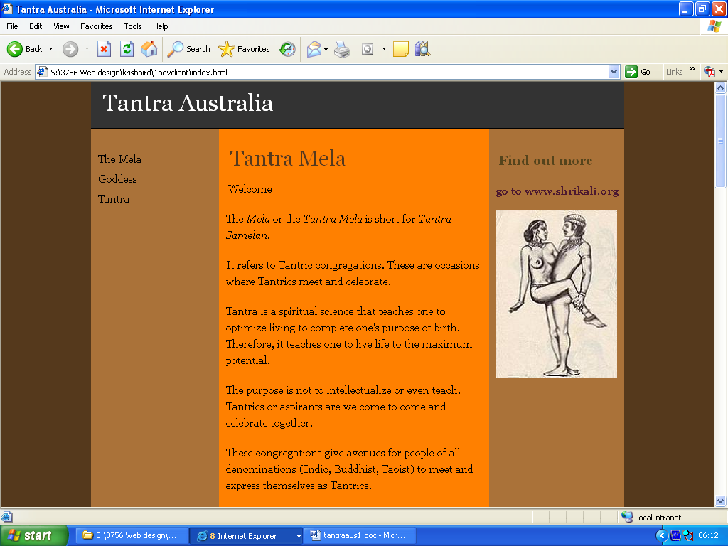


Visual Design

Layout Grids

Fixed Width

3-column fixed layout with all columns at equal heights with a a different coloured central column from the right and left-hand columns, which are the same colour. The background is again another colour. The first column is set to float left, and the second, to float right. The central column is set with margin left and margin right.

Design Sketches

Typography

Logo

Web Based Prototype

The screen shots below illustrate the Home/Index page called Tantra Mela, then two other pages, Goddess and Tantra.

- Within the main body are footnotes that provide extra information on “onclick” using Javascript. This is instead of placing them at the bottom of the page, though they could be placed there as in a conventional book.

- The name “Tantra Australia” is to be changed.

- The righthand column links to the clients’ other site “Shaiva Yoga Ashram Journal” and should post current news.

- The site should be expanded to include all the other criteria listed in this design document.

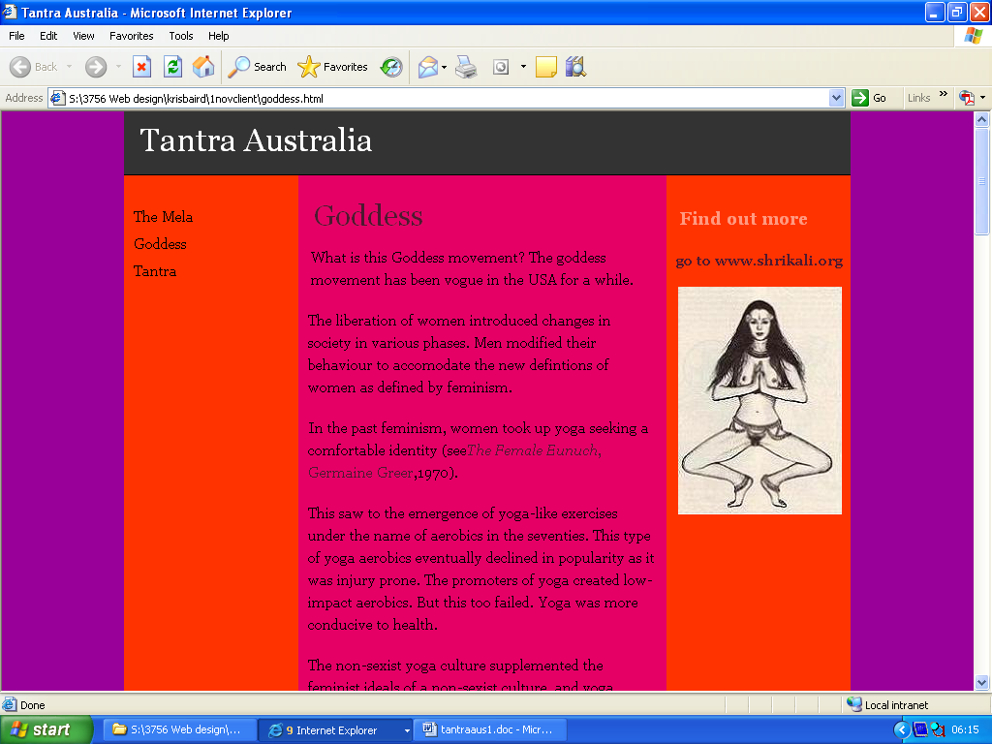
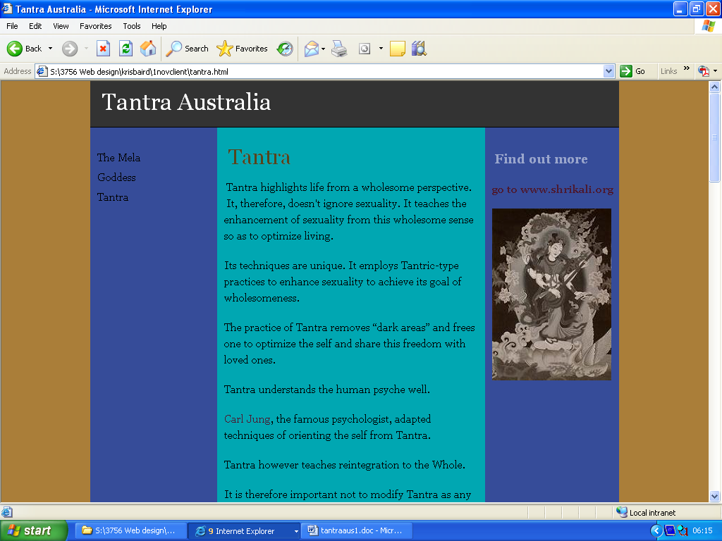

Appendix A: Competitive Analysis

The following sites represent the competition in the field of Tantra. They are chosen because they depict different angles or approaches to Tantra.

Tantraworks by Nik Douglas
http://www.tantraworks.com/

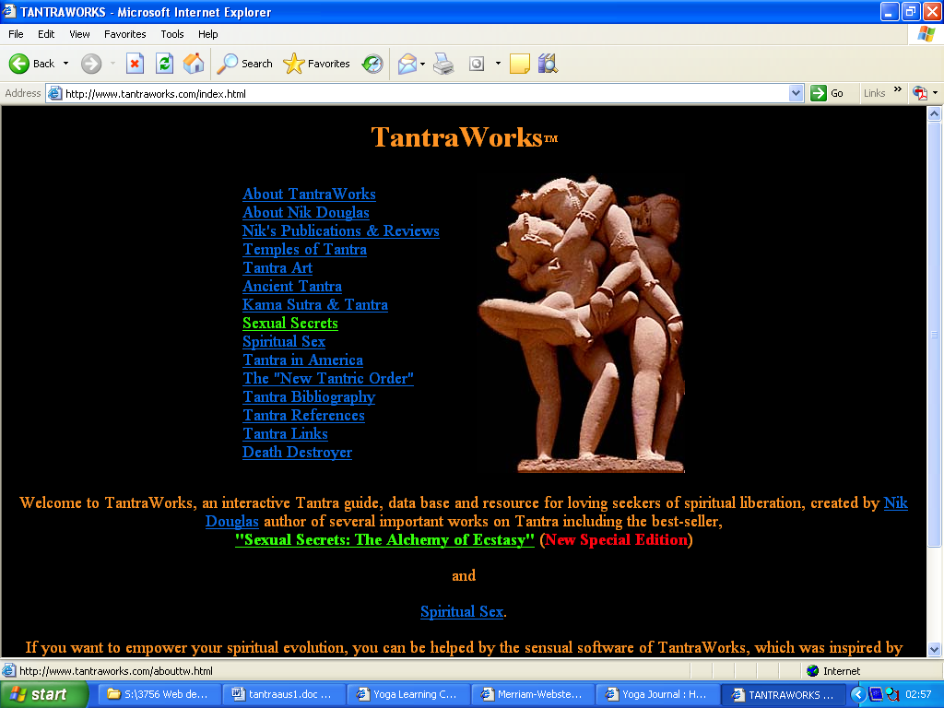
This site promotes the writings of Nik Douglas, which he has had a lot of success with, especially his book “Sexual Secrets” published together with his wife in the 70’s. He is an initiate of the Indian gurus Durga Das Shastri, a Bengali Siddha Yogi, and Gangotri Baba, who taught him Shakta Tantra. He also studied with Tibetan Rinpoches. However, he is not a teacher or even a practitioner of Tantra, being primarily a writer. It is not much of a site to emulate, but it doesn’t have to be as Nik Douglas is an established authority on the subject of Tantra due to the fame of his gurus. The last great practitioner of Tantra was Sir John Woodroffe, or Arthur Avalon (his pseudonym), a British High Court Judge based in Calcutta at the turn of the century.

International Journal of Tantric Studies
http://www.asiatica.org/ijts/

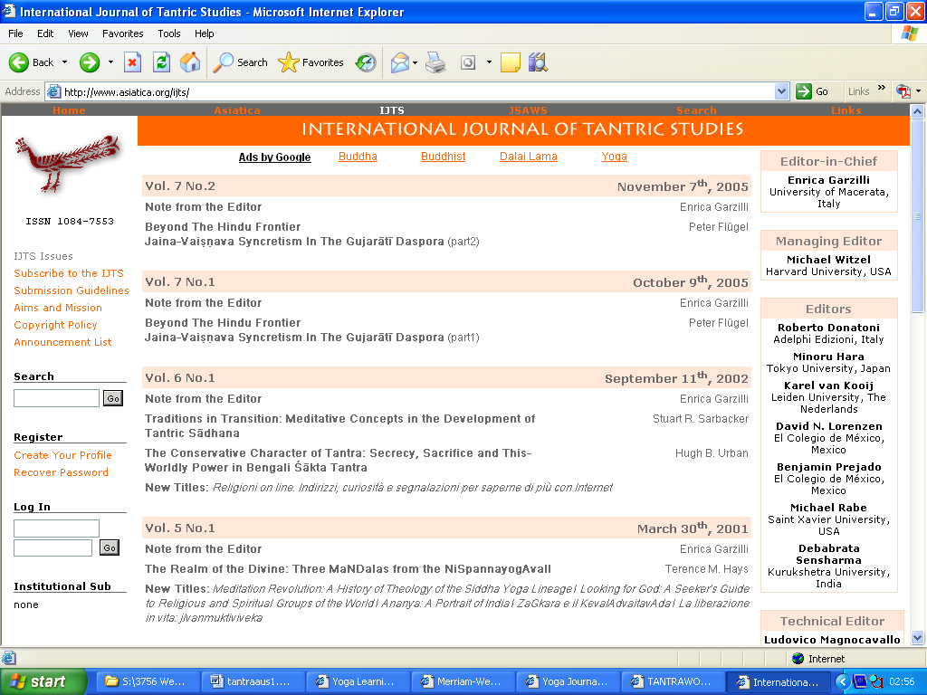
This site is dedicated to the writings of well-known modern-day scholars on Tantra. David Lorenzen, for example, provided translations of texts for the clients’ unpublished work “Divine Agamas,” the Tantric elaboration of their work “Divine Initiation.” These scholars are well-attacked throughout the clients’ websites on the grounds that you cannot intellectualise Tantra and that is why their writings are incorrect. This compares with Arthur Avalon, who was a scholar as well as a practitioner of Tantra, and whose writings are the most correct of any scholar on Tantra. This site is typically elitist of scholarly sites in the field as you have to become a member to read the material. However, it is well laid out and sleekly presented featuring various search facilities, proper use of the Sanskrit font and good usage of logos.

Buddhanet by Venerable Pannyavaro
http://www.buddhanet.net/

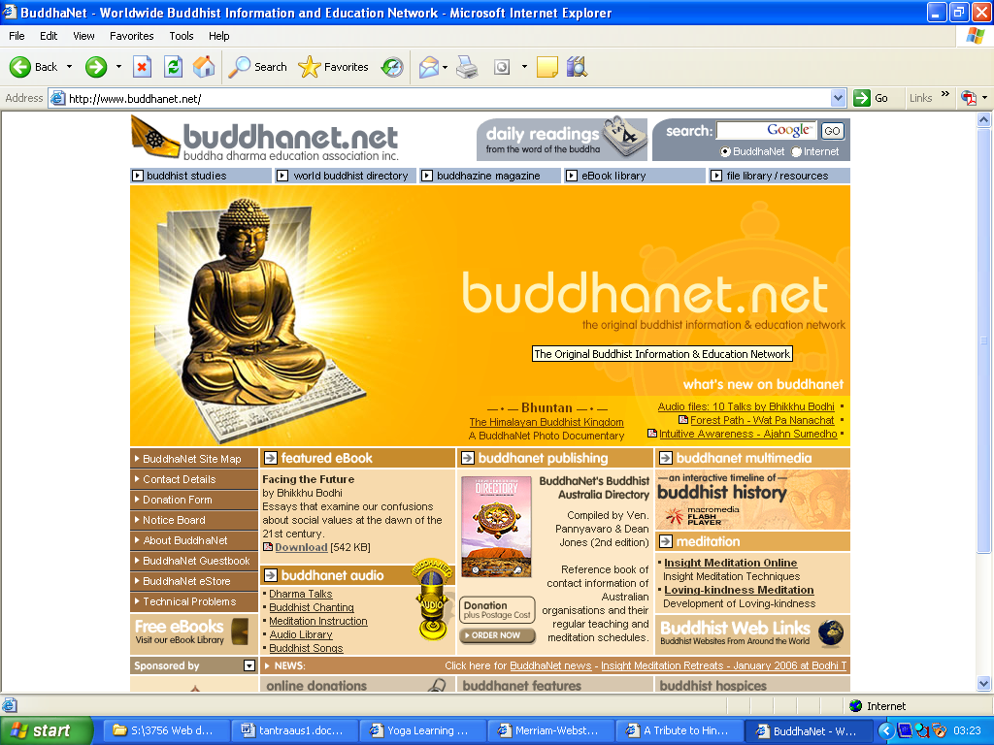
This is a well-established Buddhist portal that receives between 50,000-100,000 hits a day. Shri Kali Publications has an article posted on this site by Venerable Pannyavaro, the Australian monk who runs the site, a well-known teacher at the Buddhist Meditation Centre in Medlow Bath. This site is truly inspirational in its scope, diversity and representation of all schools of Buddhist thought, including Buddhist Tantra. It was one of the earliest Buddhist sites existing on the web, one of the reasons for its prominence. This site in fact made the monk known and today he receives funding for his site from Phor Kark See Monastery in Singapore. It has all the features necessary to maintain competitive advantage in the Buddhist arena: community noticeboard, ebooks and audio purchasing facilities, extensive material on Buddhism, a site map for easy navigation, multimedia movies available for viewing online, search facilities, and so on.

Yoga Journal
http://www.yogajournal.com/


This site is a well-established American portal in the Yoga domain with increasing awareness of the relevance of Tantra for Yoga. It is an overly commercialised site but highly successful in promoting Yoga throughout the USA. However, it started off in the days of paper magazines and established its following then; the website is merely and extension of an already established business. “Shaiva Yoga Ashram Journal” is a direct attack on this site, as revealed in the title, to try to lure readers away from this site to the clients’ site. This site has all the characteristics required to maintain competitive advantage including search bars, extensive articles with the trendsetters in Yoga and on tradition and luminaries, online subscription forms, recent news posts, free weekly email newsletters, an appended blogsite called http://blogs.yogajournal.com/, free steaming video clips, and so on. This site has the lot.

Appendix B: Content Inventory

The clients need to supply the following content for the site:

- Site Content under the navigation headings Mela (Home Page), Goddess, Tantra, Devi Puja

- Footnotes – the clients want to include footnotes within the body of the main text using Javascript’s onclick event to load/unload them

- Appropriate Images for the main content and the footnotes

- Retreat Schedules for learners/teachers of Tantra

- Application Form Criteria for learners/teachers of Tantra (eg. Interested in Left/Right-hand Tantra)

- (NB. Contact Us Information is unnecessary as prospective clients will upload queries to the server via an online form)

- Blogging Articles

- Digital Video to be converted to streaming video and audio to be uploaded

Appendix C: Client Transcript

Initial Interview

Below is a transcript of an interview held with the clients.

1. Define the site’s goals

- Who should be involved in defining the goals? Who are the decision-makers?

Bhagavan Shri Shanmukha Anantha Natha and Shri Ma Kristina Baird are defining the goals for this site. They are the key decision-makers. Their names reflect their initiation into a particular tradition of Tantra, though they claim knowledge of all the Tantras (Indic, Buddhist, Taoist and even Christian).

- What is the purpose of the organisation itself?

The purpose of “Tantra Australia” is twofold. Firstly, to introduce Australians to the ancient practice of Tantra within a modern context that is relevant to their lives. For example, Tantra can be used as a tool to help people psychologically, physically, emotionally, and socially. Secondly, to provide employment to its employees, or those interested in teaching Tantra.

- What are the site’s short-term and long-term goals?

The short-term goal of the site is to serve as a billboard that attracts clients that either want to learn or want to teach Tantra. The long-term goals of the site are to facilitate online processing of client applications, act as an instrument for marketing to a larger audience, and promote the clients’ other website “Shaiva Yoga Ashram Journal” where indepth material and translations of Tantra can be accessed.

- If the clients already have a website, what issues are they concerned about based on their previous experience?

The clients are concerned that their previous site “Shaiva Yoga Ashram Journal” is too obscure (as one friend said, you need a translator to read it). They felt that they wanted to create the “Tantra Australia” website to act as a billboard for their earlier site and to provide articles of a more contemporary and relevant nature to Australians.

- Why do the clients want to create the website?

As said above, they need a billboard, advertisement and marketing medium to promote the learning and teaching of Tantra within Australia.

- What is the scope of the website?

The scope of this site is to serve as a billboard to introduce Australians to the correct practice of Tantra. (The correct practice of Tantra is learnt from a teacher of a valid sampradaya, or oral teachings from a valid lineage.) Also the site’s scope is to show the relevance of Tantra for modern living. Initially there are contemporary articles to attract clients, online application forms, retreat schedules, and contact us forms. Eventually, the clients would like to include blogging (for revenue?), discussion threads, streaming video and other technologies to attain a modern and interesting website.

2. Define the site’s intended audience(s)

- How old is the intended audience?

The audience is professionals and semi-professionals aged 20-50.

b) What does the intended audience already know about the subject?

The intended audience knows that Yoga is a preventative health culture against unwanted illness and expenditure. Some people are aware that Yoga as Tantra satisfies one’s inner need for spiritualism so as to feel wholesome, healthy and happy. Some people equate Tantra with its purported claim to teach raising of the kundalini or chi and seek out teachers to teach this. All these reasons have led to an explosion of Tantric teaching schools in the USA in the last few years.

- Is there more than one intended audience? If so, what different audiences do you anticipate for the site?

Definitely there is a diverse audience. There are two distinct groups: those that want to learn Tantra and those that want to teach it. Those who want to learn Tantra include the corporate professionals who are fighting fatigue and stress. Tantra can help them by unconditioning them and reconditioning them into healthy patterns and giving them a break. The other audience that wants to learn Tantra is a younger audience between 20-40 who want a healthy life culture that is wholesome. They know the importance of spiritualism as a life culture. (This group would include the “Goddess Movement Culture” prominent in the USA.) Some of this group seeks out Tantra to socialise and experience a safe, enriching environment. Those that want to teach Tantra are looking for both a way of life and an income.

- What are the needs and goals for each intended audience?

Both those that want to learn and those that want to teach Tantra would be concerned about the teachers’ expertise, credibility and genuinity, as this is a field not accredited by any institution. Both audiences would be interested in the retreat schedule, price of the retreats and location and quality of the venue. Both groups would also want to know what they would learn and how much they would learn in a specific timeframe.

- What are some typical user scenarios?

Scenario 1: Natalie is a yoga teacher from Newtown, Sydney in her late 30’s. She was thinking about either learning Tantra with the Tantrananda school in Sydney or going to India and looking for a teacher. She thinks the “Tantra Australia” site might offer her a viable alternative to these options and might be able to provide her with a teaching career in Tantra.

Scenario 2: Shamani is a soccer player from Denmark (aged 25 years) touring Australia. He attended a Tantric retreat in Koh Phangan, Thailand and another in Sweden. He is already inquiring into Tantra and touring the world looking for a place to experience a spiritual life culture. He is the male counterpart of the “goddess” and not abiding by “conventional living” as he lives on his past soccer payouts.

Scenario 3: Yeshe and his partner Kunje are secondary school teachers from Alice Springs. They have been involved in running Tibetan meditation classes in Alice Springs. However, they would like to learn the aspects of Tantra that teach the raising of the kundalini or chi and possibly teach these aspects as part of their Tibetan system. They are aware that the Tibetans do not generally teach these aspects (exceptions include Namdrol-ling Nyingma Monastery in Bylakuppe, Mysore, India). They are also seeking a relaxing, healthy and wholesome summer break.

- What other sites make up the site’s competition? What features, content, and functionality do these sites offer?

Other sites that make up the site’s competition include sites on Yoga, Tantra, Ayurveda, Vedism, Buddhism, and Taoism from modern, traditional and scholarly viewpoints. As far as the content of other sites is concerned, other sites appear to offer knowledge of the science of Tantra, Yoga, Ayurveda, Vedism, Buddhism, and Taoism. However, the clients’ other site “Shaiva Yoga Ashram Journal” lists their publications and these contest all knowledge in the field for the last 500 years on the basis of discovering a lost code. The clients’ expertise is based on knowledge of this code and they offer a traditional, esoteric system that is rare. However, other sites pose an apparent “competitive advantage” because the clients are unknown and Australians perhaps look to Americans as the trendsetters in the field of Tantra. Other sites offer a far sleeker image with greater functionality that the clients aspire towards creating on this site.

3. Determine the site’s content

- What are all the pieces of content the site needs to fulfill its mission? to accomodate its scope? to stand up to its competition?

The content of the site should establish the clients’ originality, credibility, genuinity, and expertise in the field of Tantra to fufill its mission of making this knowledge available to others and providing employment for those that want to teach Tantra. To accomodate its scope, it should attract clients by providing contemporary articles highlighting the relevance of Tantra for modern living. The design of the site should appear modern, wholesome and organic to help attract clients. It should aim to incorporate the latest technologies that would help it stand up to the sophisticated image of other sites. Since the site is Australian-based, the clients can offer proximity of venue and quality of teachings for Australians desiring to learn Tantra.

- What types of functionality are required?

The site should be linked under umbrella Tantra, Yoga and Shaivism sites to increase its ranking and popularity. It should easily appear in search engines under the words “Tantra” and “Yoga.” It should incorporate pages for contemporary articles, retreat schedules, online application forms and contact us forms. It should evolve to include a google search engine, site map, blogging, discussion forums, streaming video, latest news and e-books facilities to keep clients perusing the site regularly.

- How should the various pieces of content be organised or grouped?

Mela (Congregations), Goddess, Tantra, and Devi Puja are the titles of the preliminary pages that introduce Australians to the concept of Tantra from the clients’ perspective. The retreat schedules and application forms for teachers and learners of Tantra are separate pages. Later the site should provide interactive pages, especially blogging linked to the site and/or discussion forums. Access to streaming videos of events and pujas (worships) should be another section. For indepth translations of Tantric texts, users are redirected to “Shaiva Yoga Ashram Journal.” Both sites should aim to become fully developed web presences.

Appendix D: Technical Considerations

Domain Name

Tantrayoga.org.au was chosen as the site’s domain name for two reasons. One, it is hoped that under the keyword search for the words “tantra” and/or “yoga” that this site would appear prominently in the listings. Secondly, the words “tantrayoga” denote a valid yoga tradition. The site is designated as an organisation because it should attain non-profit status. It is registered in Australia as this is a specifically Australian targeted site. However, it is likely that the site’s name “Tantra Australia” will be changed.

Hosting

Hosting was chosen with 3ix.org. This corresponds with the hosting for the clients’ other site, “Shaiva Yoga Ashram Journal.” This hosting company provided a free trial period for one month that proved satisfactory for the clients’ other site. They are US-based and seemed to demonstrate the latest technologies. Their hosting fee was also economical at a rate of US $9 for six months. However, if economic constraints allow it may be advisable to host “Tantra Australia” with DreamHost at a cost of US $9.95 a month plus a US $49.95 setup fee or a cost of US $7.95 a month with no setup fee but prepaid for two years. This would allow “Shaiva Yoga Ashram Journal” to be shifted to DreamHost at no additional cost at the end of its hosting period in 3 months time. Also DreamHost has extra technologies available like PHP, QuickTime Streaming and Ruby on Rails that would be advantageous in the future.

